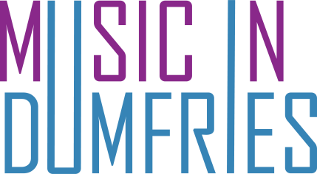 gift aid it
Registered Charity number SC012367

Gift Aid declaration
Please treat as Gift Aid donations all qualifying gifts of money made
today □ in the future □
(Please tick all boxes you wish to apply).
I confirm I have paid or will pay an amount of Income Tax and/or Capital Gains Tax for each year (6 April to 5 April) that is at least equal to the amount of tax that all the charities which I support will reclaim on my gifts. I understand that other taxes such as VAT and Council Tax do not qualify. I understand that the charity will reclaim 25p on every £1 that I give.

Donor’s Details

Title ______ First name or initials_____________________________

Surname_________________________________________________
Full home address_________________________________________
________________________________________________________
Postcode ________________

Date ____________________ Signature ______________________

Please notify the charity, Music in Dumfries, if you:
- want to cancel this declaration
- change your name or home address
- no longer pay sufficient tax on your income and/or capital gains

If you pay Income Tax at the higher or additional rate and want to receive the additional tax
relief due to you, you must include all your Gift Aid donations on your Self Assessment tax
return or ask HM Revenue and Customs to adjust your tax code.

